

**The Apples Medical Centre – November 2024 Newsletter**

**Apples PG Chair notes November 2024**

Patient Participation Survey – We conducted a survey for the month of October, thank you to everyone who took the time to complete the survey.

We are now calculating and reviewing the results and will inform patients with the outcome.

You will remember the opening of the new treatment rooms, and they are working very well, despite having a second entrance. This is an example of our surgery changing and improving. The new phone system is another example, and although different from the “old”, it will take time for all of us to get used to its operation, and a sensible feedback of any issues that do not seem to work will be very welcome. Happy for you to send those to me or Philippa.

Well November is here and winter with its health issues, is on us again. Vaccinations are concluded so I do hope your health will be good over this period.

**In the meantime, stay healthy. Bruce Duncan, PPG Chair**

**bruceduncanab@gmail.com**

**PRACTICE CHANGES:**

**In Junes Newsletter we mentioned that we were going to review a few of our process, our aim is to improve patient’s experience;**

**TELEPHONE SYSTEM:** Go Live 5th December; here is a list of some of the new features; call queuing, call back, monitoring calls waiting etc.

Five new options to choose.

1- Appointments

2- Prescription phone line

3- Care Coordinator

4- Secretarial

5- Reception

The new telephone system is a big change to our current old system, please bear with us whilst we implement this change.

**APPOINTMENTS:** this goes live from 1st December:

* Urgent – to be seen on the day by any clinician, urgent appointments only.
* Non-urgent – to be seen within 2 weeks.
* Routine – to be seen within 4 weeks, follow up appointments.
* Urgent Telephone calls – to be called on the day.
* Routine Telephone calls – follow up phone calls.

We need to make these changes to ensure we can continue to look after our clinicians and you as our patients. We are making these changes to make best use of the time and resources we have available. This ensures we are able to see those with urgent needs on the same day.

We aim to offer non-urgent appointments within two weeks. This approach allows us to prioritize urgent cases while still providing timely care for all our patients.

When you book an appointment our reception team will ask you a few questions about your needs. These questions help us understand the nature of your visit so that we can direct you to the most suitable clinician as quickly as possible.

If the surgery does not have any more GP or Nurse Practitioner appointments left for urgent appointments the reception team have been instructed to inform patients, the following:

* *“The GPs have asked me to let you know that we have no more appointments, we recommend you call 111, please inform 111 that my GP have no appts available.*

If the surgery does not have any more nursing appointments left for dressings, then the reception team have been instructed to direct patients to the MIU Yeatman hospital.

**TEST RESULTS:** this goes live from 2nd January 2025

**Normal/Satisfactory results:**

If your results are normal/satisfactory the surgery will no longer contact you, the results will be on your NHS App.

If after 5 working days your results are not showing on your App, you can contact the reception team, for normal results the reception team have been given permission by the GP to inform you of the results.

**Abnormal results:**

Your clinician who requested your test should have arranged a follow up appointment/phone call or will contact you once the tests are back from the path lab – results usually take around five working days to come back.

**NHS App:**

The NHS App allows patients using the National Health Service in England to book appointments with their GP, order repeat prescriptions and access their GP record.

We encourage all our patients to download the NSH App; Dorset council are running sessions at Sherborne Library to help patients with the NHS App/and other online services:

* Thursdays 2-4pm
* Fridays 11am-1pm

**Practice Workforce update:**

 Sarah Sutcliffe Practice Nurse had a beautiful baby girl back in June 2024! Congratulations to all!

**DISPENSARY CHANGE TO OPENING TIMES:**

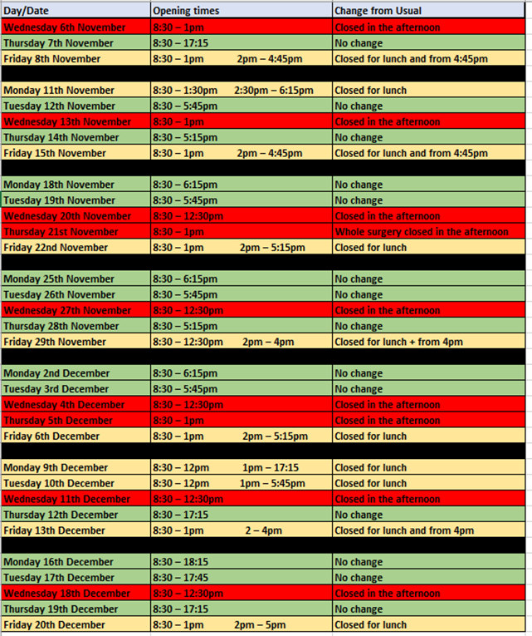Due to current staff shortages in our dispensary, we will be adjusting our opening hours over the next few months. This change is necessary to ensure that we can continue to provide safe and efficient service to all our patients. Please see opening times, also this is displayed via our website and Facebook page.

**NURSING TEAM:**

Our nursing team is currently experiencing staffing shortages, as a result you may experience longer wait times for an appointment than usual. Please know that we are actively working to recruit additional staff to bring our nursing team back to full strength and improve appointment availability.

We apologise for any inconvenient this may cause and appreciate your understanding during this time. Thank you for your patience as we work through these temporary staffing challenges.

**Dates for the Diary:**

**Thursday 21st November – Practice closure from 2pm (for emergencies contact the Practice mobile or 111, for medical emergencies phone 999)**

**CHRISTMAS CLOSED DATES:**

**Wednesday 25th December, Christmas Day – CLOSED**

**Thursday 26th December, Boxing Day – CLOSED**

**Wednesday 1st January, New Years Day – CLOSED**

**If you require medical assistance during surgery closures, phone 111 or 999 in the case of an emergency.**